**Experiment – 2**

**Student Name:Vedant**

**Branch: BE-CSE**

**Semester: 6th**

**Subject Name: AP Lab - 2**

**UID: 22BCS10618**

**Section/Group: NTPP - 603/B Date of Performance: 11/01/24 Subject Code: 22CSP-351**

**Problem-1**

1. **Aim :** Two Sum
2. **Objective :**

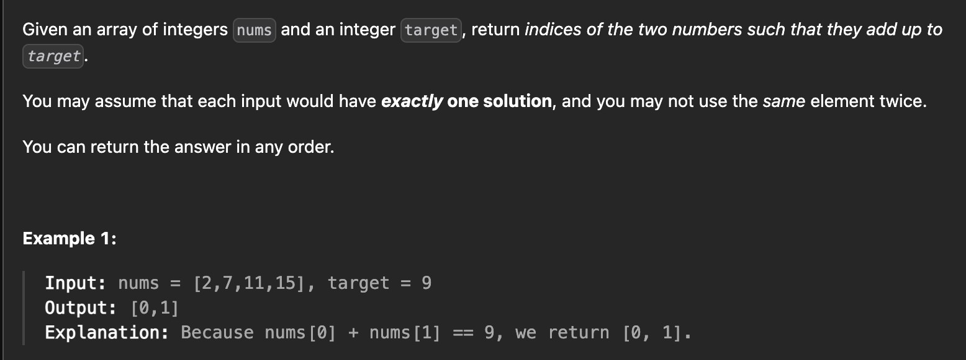

1. **Implementation & Output :**

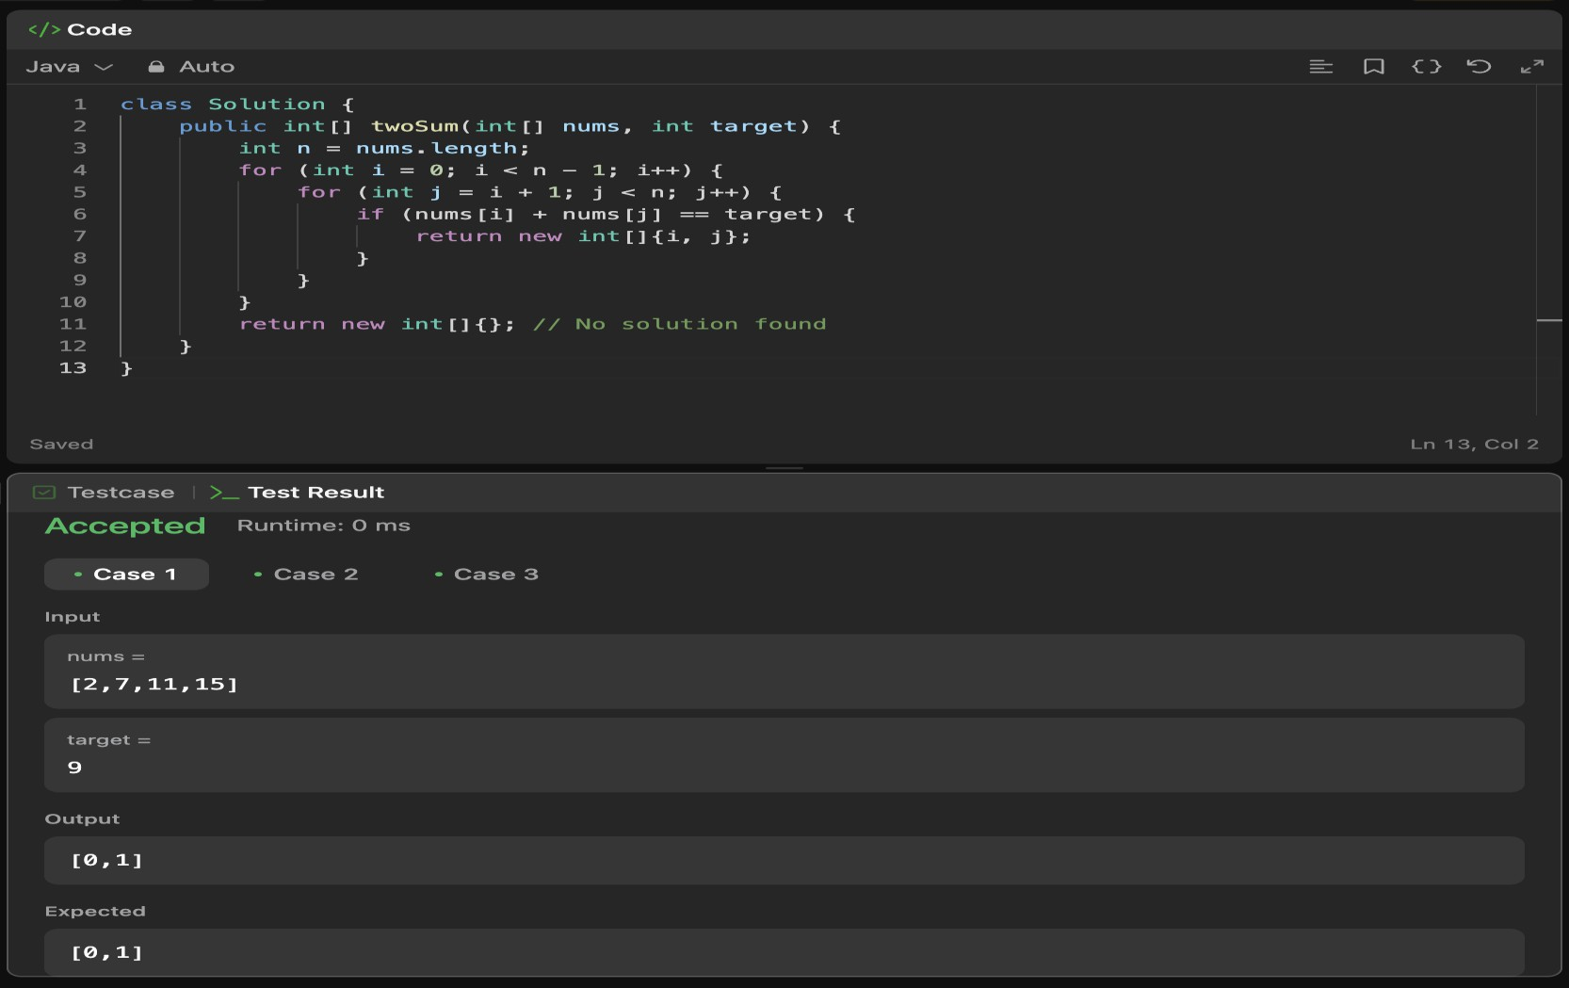

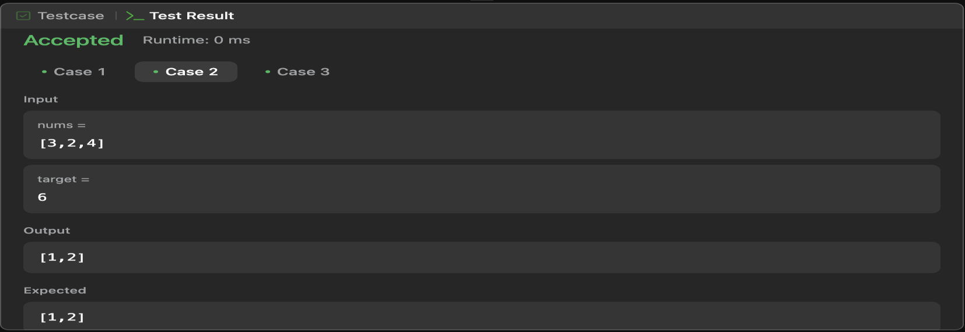

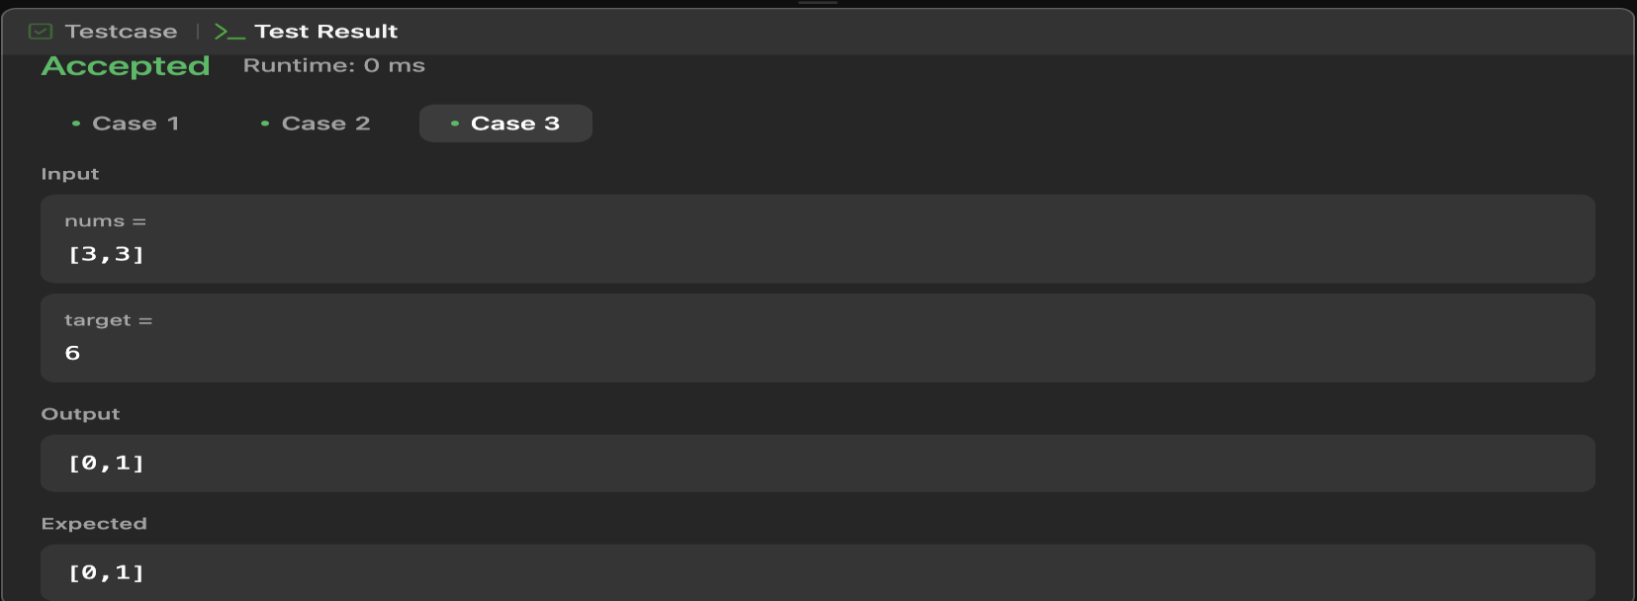

1. **Learning Outcomes :**
   * **Nested Loops:** Demonstrates how to iterate through all pairs of elements in an array using nested loops.
   * **Brute Force Approach:** Solves the problem using a brute force method with O(n²) time complexity, highlighting its inefficiency for large inputs.
   * **Array Indexing:** Teaches how to access and compare elements in an array by their indices.
   * **Edge Case Handling:** Handles cases where no solution is found by returning an empty array

**Problem-2**

1. **Aim : Jump Game**
2. **Objective :**

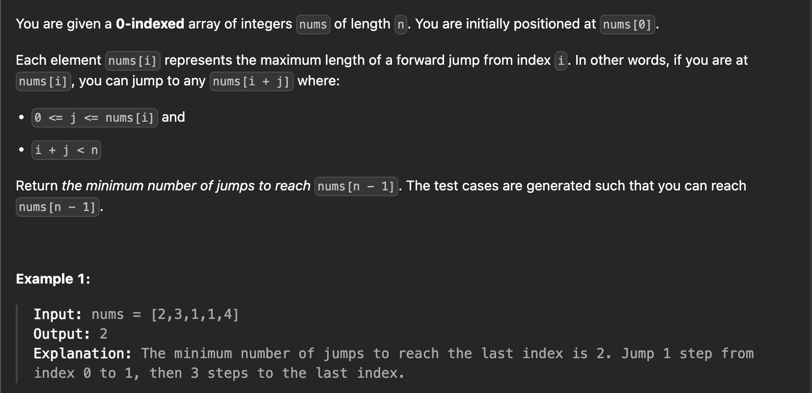

1. **Implementation & Output :**

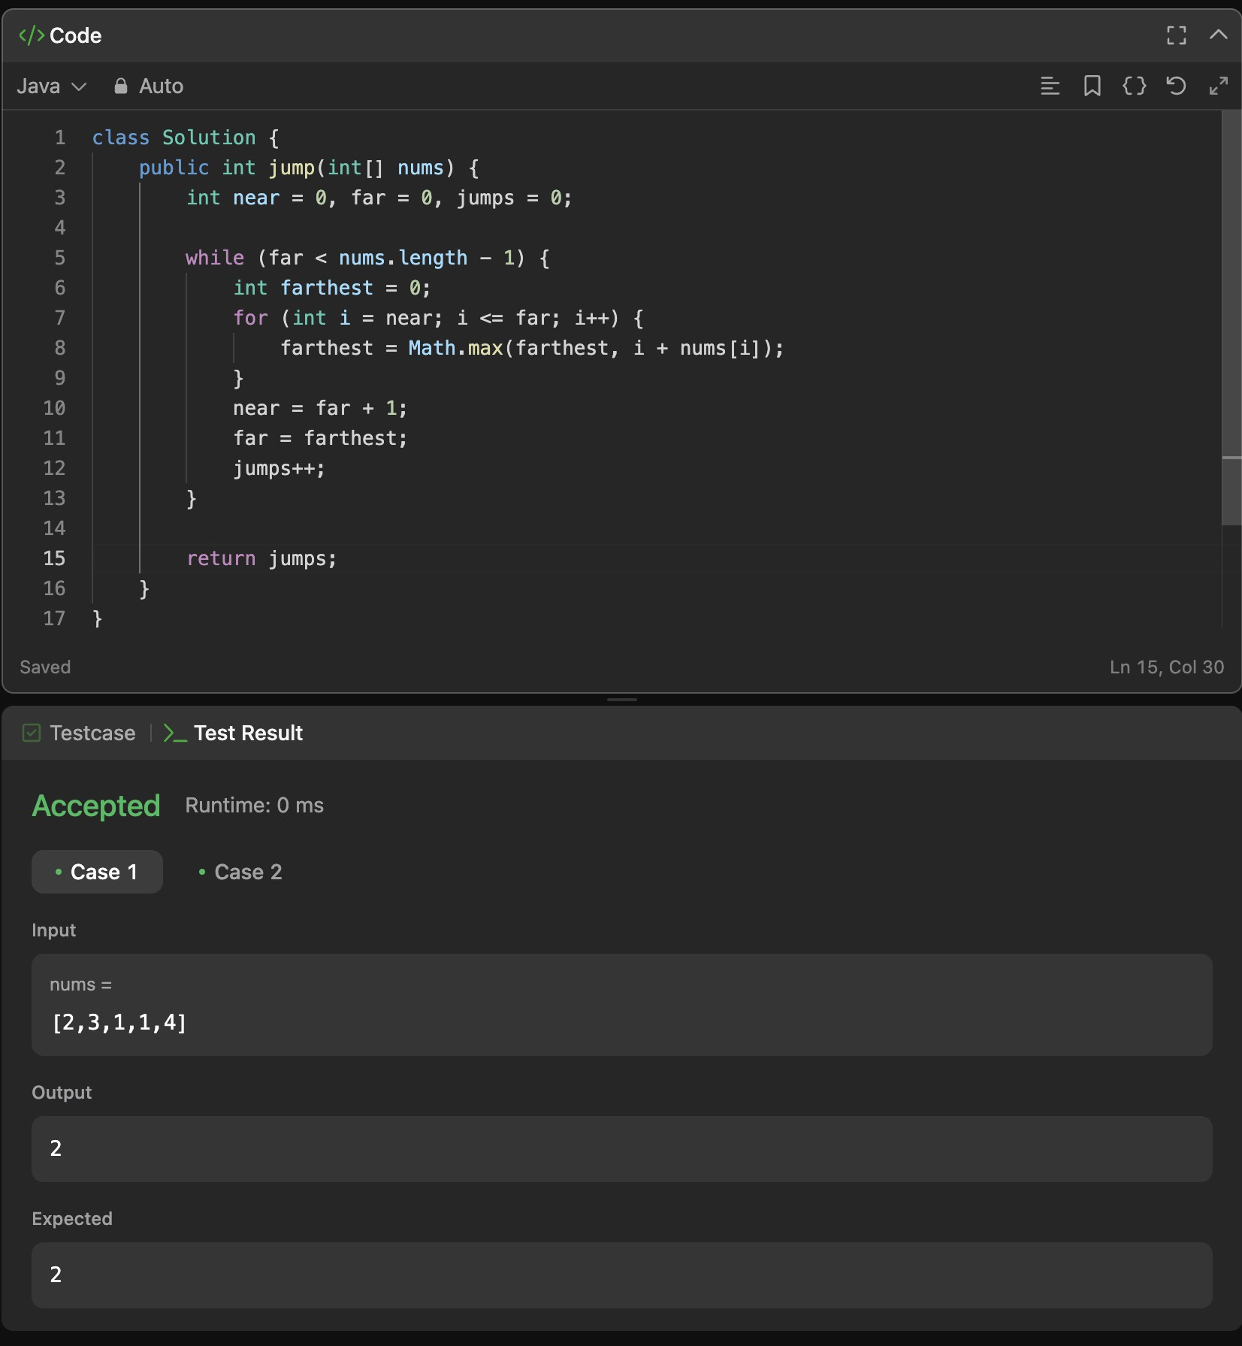

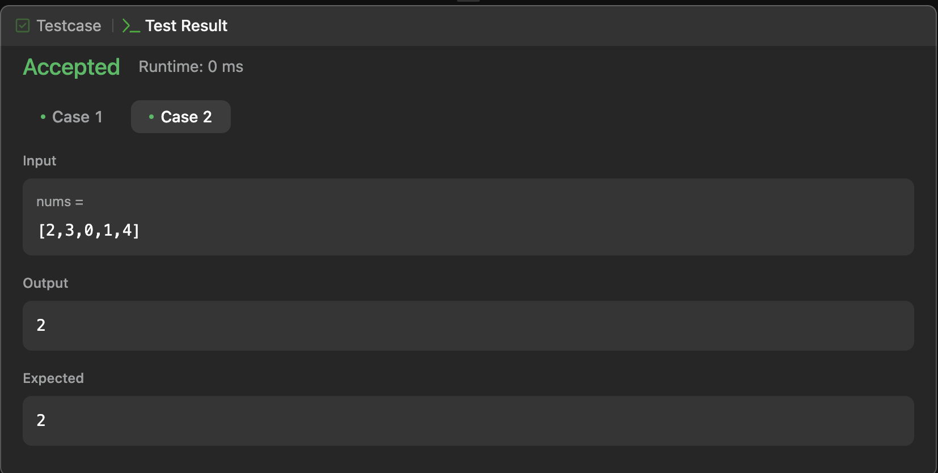

1. **Learning Outcomes :**
   * **Greedy Strategy:** Learn how to apply a greedy approach to solve optimization problems by always choosing the farthest reachable index to minimize jumps.
   * **Two Pointer Technique:** Understand how to use two pointers (near and far) to track the current jump range and expand it iteratively.
   * **Efficient Jump Calculation:** Learn to calculate the minimum number of jumps required to reach the end of an array while traversing the input only once.
   * **Time Complexity Awareness:** Recognize that the algorithm operates in O(n) time complexity, optimizing performance over brute force methods.